St Hilda’s Ashford

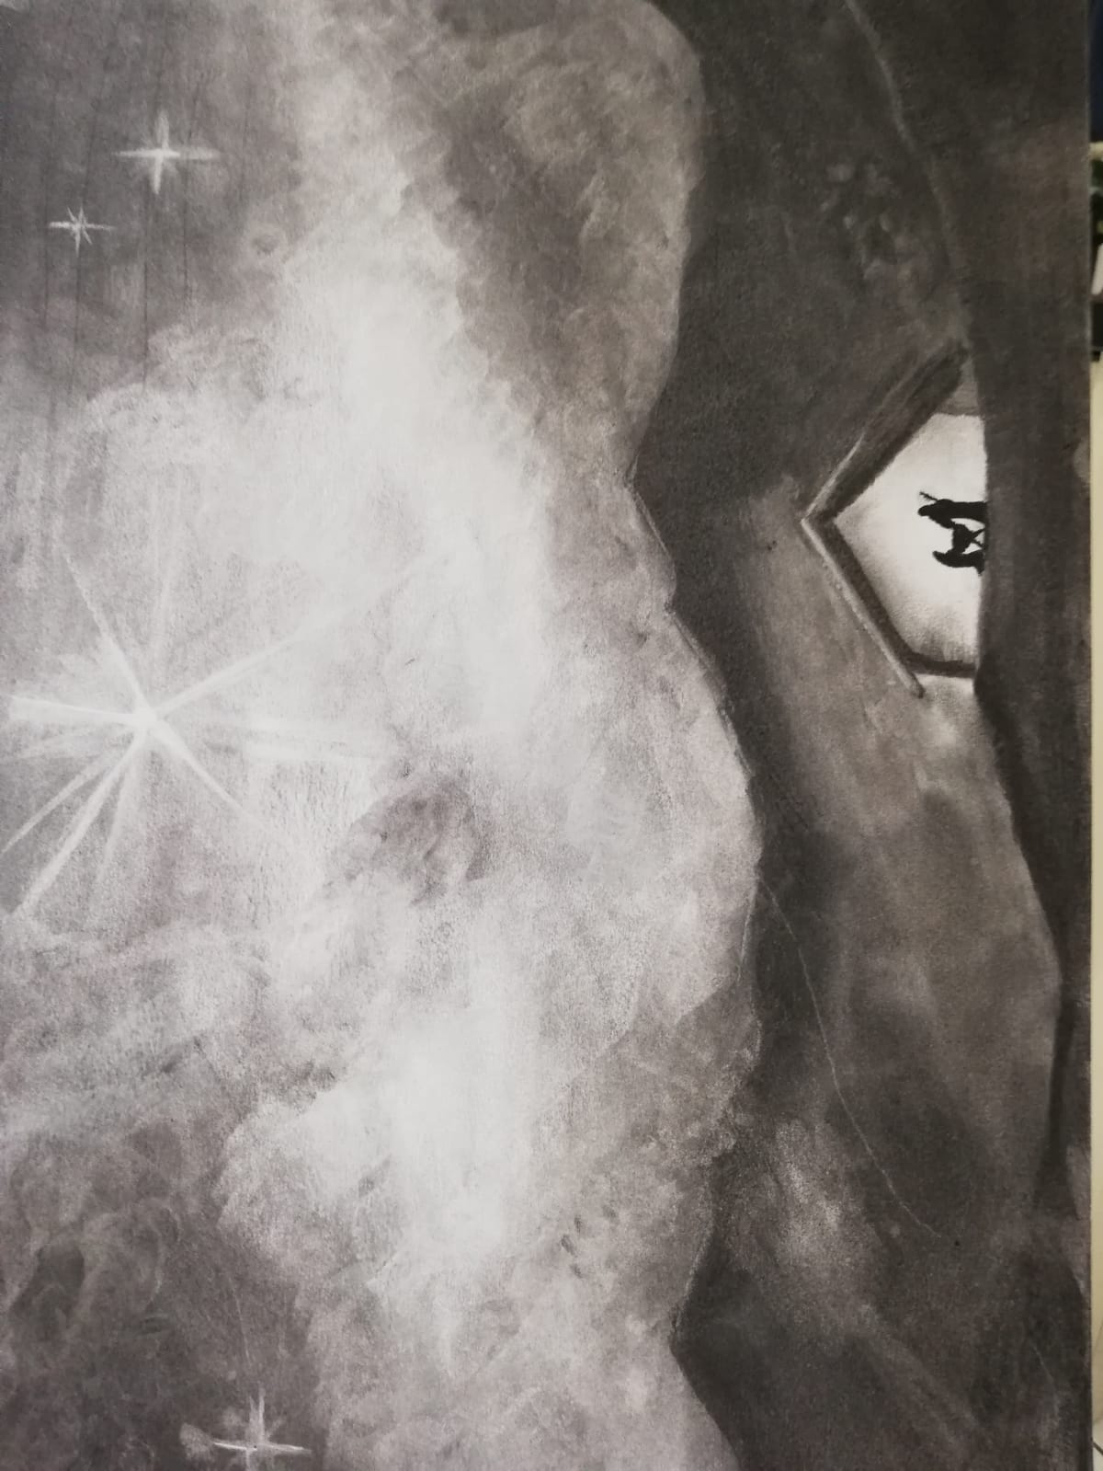

Christmas Day Eucharist

The Greeting
In the name of the Father,
and of the Son,
and of the Holy Spirit.
All Amen.
The Lord be with you
All and also with you.

The Christmas Candle
Light and peace in Jesus Christ our Lord
All Thanks be to God.
Today is Christmas Day, in which we recall the hope we have in Christ. Today we light again the candles of hope, peace, love and joy.
(Each candle will be lit as the reader speaks)
Blessed are you, sovereign Lord, King of peace:
to you be praise and glory for ever.
The new light of your incarnate Word
gives gladness in our sorrow,
and a presence in our isolation.
Fill our lives with your light,
until they overﬂow with gladness and praise.
Blessed be God for ever.
(We light the fifth candle, to mark the Birth of Christ)
People of God: shout and sing!
Tell the good news of peace on earth.
Lord, bring us today into Christ’s peace.
All God’s people shout:
Amen!

Angels dance
and the bright star shines.
All creation bows to the Lord of all.
Lord, bring us today into Christ’s light.
All God’s people shout:
Amen!
One with us,
yet born to save,
he will show us the way to God.
Lord, bring us today into Christ’s love.
All God’s people shout:
Amen!

People of God: shout and sing:
Alleluia! Alleluia!
Amen.

Invitation to confession
Hear the words of the angel to Joseph:
‘You shall call his name Jesus,
for he will save his people from their sins.’
Therefore let us seek the forgiveness of God
through Jesus the Saviour of the world.
Lord of grace and truth,
we confess our unworthiness
to stand in your presence as your children.
We have sinned:
All forgive and heal us.
The Virgin Mary accepted your call
to be the mother of Jesus.
Forgive our disobedience to your will.
We have sinned:
All forgive and heal us.
Your Son our Saviour
was born in poverty in a manger.
Forgive our greed and rejection of your ways.
We have sinned:
All forgive and heal us.
The shepherds left their flocks
to go to Bethlehem.
Forgive our self-interest and lack of vision.
We have sinned:
All forgive and heal us.
The wise men followed the star
to find Jesus the King.
Forgive our reluctance to seek you.
We have sinned:
All forgive and heal us.

Almighty God,
who forgives all who truly repent,
have mercy upon you,
pardon and deliver you from all your sins,
confirm and strengthen you in all goodness,
and keep you in life eternal;
through Jesus Christ our Lord.
All Amen.

The Collect – our Prayer for the Day
Lord Jesus Christ,
your birth at Bethlehem
draws us to kneel in wonder at heaven touching earth:
accept our heartfelt praise
as we worship you,
our Saviour and our eternal God.
Amen.

The Liturgy of the Word

First Reading- Isaiah 52: 7-10

How beautiful upon the mountains
are the feet of the messenger who announces peace,
who brings good news,
who announces salvation,
who says to Zion, “Your God reigns.”
Listen! Your sentinels lift up their voices,
together they sing for joy;
for in plain sight they see
the return of the Lord to Zion.
Break forth together into singing,
you ruins of Jerusalem;
for the Lord has comforted his people,
he has redeemed Jerusalem.
The Lord has bared his holy arm
before the eyes of all the nations;
and all the ends of the earth shall see
the salvation of our God.

At the end the reader may say

This is the word of the Lord

All Thanks be to God.

Second Reading – Hebrews 1: 1-12

Long ago God spoke to our ancestors in many and various ways by the prophets, but in these last days he has spoken to us by a Son, whom he appointed heir of all things, through whom he also created the worlds. He is the reflection of God’s glory and the exact imprint of God’s very being, and he sustains all things by his powerful word. When he had made purification for sins, he sat down at the right hand of the Majesty on high, having become as much superior to angels as the name he has inherited is more excellent than theirs.
For to which of the angels did God ever say,
“You are my Son;
today I have begotten you”?
Or again,
“I will be his Father,
and he will be my Son”?
And again, when he brings the firstborn into the world, he says,
“Let all God’s angels worship him.”
Of the angels he says,
“He makes his angels winds,
and his servants flames of fire.”
But of the Son he says,
“Your throne, O God, is forever and ever,
and the righteous scepter is the scepter of your kingdom.
You have loved righteousness and hated wickedness;
therefore God, your God, has anointed you
with the oil of gladness beyond your companions.”
And,
“In the beginning, Lord, you founded the earth,
and the heavens are the work of your hands;
they will perish, but you remain;
they will all wear out like clothing;
like a cloak you will roll them up,
and like clothing they will be changed.
But you are the same,
and your years will never end.”

At the end the reader will say

This is the word of the Lord

All Thanks be to God.

Gospel Reading – John 1:1-14

Alleluia, alleluia.
The Word became flesh and dwelt among us,
and we have seen his glory.
Alleluia.
When the Gospel is announced the reader says
Hear the Gospel of our Lord Jesus Christ according to Luke.
All Glory to you, O Lord.

In the beginning was the Word, and the Word was with God, and the Word was God. He was in the beginning with God. All things came into being through him, and without him not one thing came into being. What has come into being in him was life, and the life was the light of all people. The light shines in the darkness, and the darkness did not overcome it.
There was a man sent from God, whose name was John. He came as a witness to testify to the light, so that all might believe through him. He himself was not the light, but he came to testify to the light. The true light, which enlightens everyone, was coming into the world.
He was in the world, and the world came into being through him; yet the world did not know him. He came to what was his own, and his own people did not accept him. But to all who received him, who believed in his name, he gave power to become children of God, who were born, not of blood or of the will of the flesh or of the will of man, but of God.
And the Word became flesh and lived among us , and we have seen his glory, the glory as of a father’s only son, full of grace and truth.

This is the Gospel of the Lord.

All Praise to you, O Christ.

Sermon – All sit

The Creed – All stand
Do you believe and trust in God the Father,
source of all being and life,
the one for whom we exist?
All We believe and trust in him.
Do you believe and trust in God the Son,
who took our human nature,
died for us and rose again?
All We believe and trust in him.
Do you believe and trust in God the Holy Spirit,
who gives life to the people of God
and makes Christ known in the world?
All We believe and trust in him.
This is the faith of the Church.
All This is our faith.
We believe and trust in one God,
Father, Son and Holy Spirit.
Amen.

Prayers of Intercession

Lord, in your mercy

All hear our prayer.

At the end

Merciful Father

All accept these prayers

for the sake of your Son,

our Saviour Jesus Christ.

Amen.

The Peace

Unto us a child is born, unto us a son is given,
and his name shall be called the Prince of Peace.
The peace of the Lord be always with you
All and also with you.
Let us offer one another a sign of peace.

Word made flesh, life of the world,
in your incarnation you embraced our poverty:
by your Spirit may we share in your riches.
Amen.

The Eucharistic Prayer

The Lord be with you
All and also with you.
Lift up your hearts.
All We lift them to the Lord.
Let us give thanks to the Lord our God.
All It is right to give thanks and praise.
It is right to praise you, Father, Lord of all creation;
in your love you made us for yourself.
When we turned away
you did not reject us,
but came to meet us in your Son.
All You embraced us as your children
and welcomed us to sit and eat with you.
In Christ you shared our life
that we might live in him and he in us.
All He opened his arms of love upon the cross
and made for all the perfect sacrifice for sin.
On the night he was betrayed,
at supper with his friends
he took bread, and gave you thanks;
he broke it and gave it to them, saying:
Take, eat; this is my body which is given for you;
do this in remembrance of me.
All Father, we do this in remembrance of him:
his body is the bread of life.
At the end of supper, taking the cup of wine,
he gave you thanks, and said:
Drink this, all of you; this is my blood of the new covenant,
which is shed for you for the forgiveness of sins;
do this in remembrance of me.
All Father, we do this in remembrance of him:
his blood is shed for all.
As we proclaim his death and celebrate his rising in glory,
send your Holy Spirit that this bread and this wine
may be to us the body and blood of your dear Son.
All As we eat and drink these holy gifts
make us one in Christ, our risen Lord.
With your whole Church throughout the world
we offer you this sacrifice of praise
and lift our voice to join the eternal song of heaven:
All Holy, holy, holy Lord,
God of power and might,
Heaven and earth are full of your glory.
Hosanna in the highest.
Blessed is he who comes in the name of the Lord;
Hosanna in the highest.

The Lord’s Prayer

Let us pray with confidence as our Saviour has taught us

All Our Father, who art in heaven,
hallowed be thy name;
thy kingdom come;
thy will be done;
on earth as it is in heaven.
Give us this day our daily bread.
And forgive us our trespasses,
as we forgive those who trespass against us.
And lead us not into temptation;
but deliver us from evil.
For thine is the kingdom,
the power and the glory,
for ever and ever.
Amen.

Breaking of the Bread

We break the bread of life,
and that life is the light of the world.
All God here among us,
light in the midst of us,
bring us to light and life.
Christ is the true bread which has come down from heaven.
All Lord, give us this bread always.

Agnus Dei

All Lamb of God,
you take away the sin of the world,
have mercy on us.

Lamb of God,
you take away the sin of the world,
have mercy on us.

Lamb of God,
you take away the sin of the world,
grant us peace.

Giving of Communion

God’s holy gifts for God’s holy people.
All Jesus Christ is holy,
Jesus Christ is Lord,
to the glory of God the Father.

The people and president receive communion.

Prayers after Communion

God our Father,
whose Word has come among us
in the Holy Child of Bethlehem:
may the light of faith illumine our hearts
and shine in our words and deeds;
through him who is Christ the Lord.
All Amen.
All Almighty God,
we thank you for feeding us
with the body and blood of your Son Jesus Christ.
Through him we offer you our souls and bodies
to be a living sacrifice.
Send us out in the power of your Spirit
to live and work to your praise and glory. Amen.

The Dismissal

May the Father,
who has loved the eternal Son
from before the foundation of the world,
shed that love upon you his children.
All Amen.
May Christ,
who by his incarnation gathered into one
things earthly and heavenly,
fill you with joy and peace.
All Amen.
May the Holy Spirit,
by whose overshadowing Mary became the God-bearer,
give you grace to carry the good news of Christ.
All Amen.
And the blessing of God almighty,
the Father, the Son, and the Holy Spirit,
be among you and remain with you always.
All Amen.

Go in peace. Proclaim the Word made flesh.
All Glory, thanks and praise to God.

Copyright Acknowledgement
©The Archbishops’ Council 2000

Cover illustration by Andrew Milton

Contacts
Vicar
Fr Joseph Fernandes
Vicar@sthilda.org Parish Office 01784 253525
Vicarage 01784 254237 Mobile 07999 053433

Licenced Lay Ministers
Carolyn Clark Carolyn@sthilda.org
Rosalyn Young rosalyn@sthilda.org

Mail & Phone via Parish Office [01784 253525]

Churchwardens
Bobbie Bedford and Stuart Young
Mail & Phone via Parish Office [01784 253525] office@sthilda.org

PCC Secretary
Denise Buttigieg
Mail & Phone via Parish Office [01784 253525] office@sthilda.org

Parish Administrator
Denise Buttigieg 01784 253525 office@sthilda.org
Church Hall Bookings
Please contact the Parish Office.

The Parish Office:
St Hilda's Church, Stanwell Road, Ashford, Middlesex
TW15 3QL

Telephone 01784 253525 Charity Number 1134119

CCLI: 708985

Follow us on Facebook https://www.facebook.com/StHildaAshford/
Follow us on Twitter https://twitter.com/StHildaAshford

