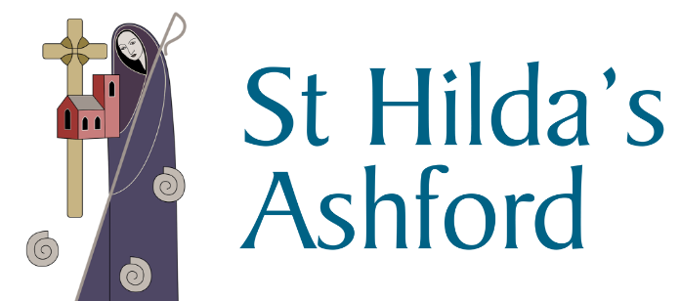 Weekly Newsletter
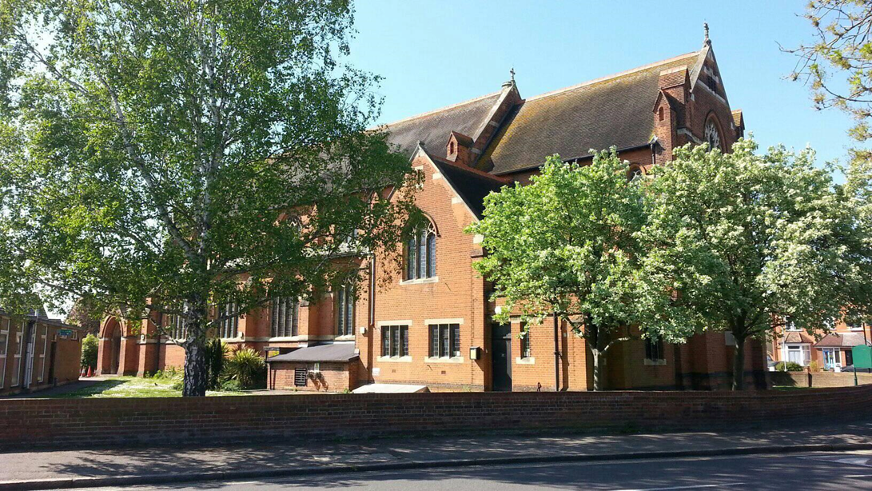
Photo courtesy of Chris Maddock

Contents

Top tips for a better mood – Many of us have found our daily routines disrupted and we’ve had to find new structures to keep us emotionally and spiritually healthy.

VE Day 75 – Bruno Peak, Pageantmaster VE Day 75

St Hilda’s ‘Skype’ choir – Christina Veasey writes.

St Hilda’s Outreach – Sleeping bag appeal
Stewardship / Donations

Our thoughts and prayers – Those from this weeks notices

If you would like help or to speak to a member of the ministry team please contact the office on 01784 253525 or office@sthilda.org Father Joseph can be contacted on 01784 254237.
TOP TIPS FOR A BETTER MOOD

Many of us have found our daily routines disrupted and we’ve had to find new structures to keep us emotionally and spiritually healthy.

1. Walk for 20 minutes per day!
Get your daily exercise – 10,000 steps should be the aim!
2. Expose yourself to full spectrum light
It increases your Serotonin hormone, which makes you feel good.
If you are indoors you get about 50-100 units of light per hour, but outdoors you get about 7000-10,000 units of light per hour.
You also get Vitamin D – which helps your nervous system.
3. Practice Breathing
Breathe in for 7 and out for 11. This kind of breathing engages your parasympathetic nervous system. Basically, it elevates your rational brain and reduces your emotional brain.
4. Take Omega 3 – it improves your brain function.
5. Gratitude is the most effective practice for stimulating feelings of happiness, as it literally transforms our brain.
It changes the structure of our brain and keeps our grey matter functioning, which makes us feel healthier and happier.
Why not think of 3 things each morning/evening that you are thankful for?

VE Day 75
When VE Day dawns on 8th May 2020 it will be 75 years since the guns fell silent at the end of the war in Europe. Years of carnage and destruction had come to an end and millions of people took to the streets and pubs to celebrate peace, mourn their loved – ones and to hope for the future, but not forgetting those still in conflict until 15th August when it was announced that Japan had surrendered unconditionally to the Allies, effectively ending World War II.
The 75th anniversary will provide our nation, and our friends around the world, with an opportunity to reflect on the enormous sacrifice, courage and determination of people from all walks of life who saw us through this dark and terrifying period.
We will remember the members of the Armed Forces and Merchant Navy from many countries who gave their lives or returned home injured in body and mind, the hard-working women and men who operated the factories, mines, shipyards and farms, and ARP wardens, police officers, doctors, nurses, fireman, local defence volunteers and others who toiled day and night selflessly on the home front during difficult frightening and uncertain times.
Bruno Peek, Pageantmaster VE Day 75

St Hilda’s ‘Skype’ Choir – Keeping music playing during lockdown
We have been busy supporting Father Joseph with music for his ‘live’ Vicarage broadcasts each Sunday! Thus various Choir members have been over-coming the challenges of ‘home audio-recording’ using computer software (and/or mobile apps) to record this music.
If interviewed, all recording their voices against pre-recording accompaniments, would likely report this as daunting and sometimes frustrating process. Indeed, many expletives are reported though happily only heard within individual homes. Moreover errors and nervous responses are made by all.

Skype or Zoom software (free - not sales talk) has been invaluable for keeping in touch during lockdown. Unsurprisingly, email continues to bring challenge, and sometimes confusion, especially if venturing ‘good ideas’ or offering ‘nerdy’ knowledge so essential to overall improvement and better quality music-making. As many can guess, recording this way demonstrates warts and all. Significantly also commercial streaming regulations requires us to do it all ourselves, or not at all!
Crucially, St Hilda’s choirs wish to maintain their successful music reputation but….

‘We need more singers now.’ No music knowledge is necessary, just wanting to sing.
Do join us - we’d love to welcome you.

Christina A Veasey
Music Director and Organist
Home Tel/Ans; 01256 397125
Email; christina.veasey@btinternet.com
Or via; Parish Office: 01784 253525

Crossroads
Please email Rosemary at crossroads_ashford@hotmail.com if you have anything to be included in the parish magazine. The most recent edition is available on our website.
2 Corinthians 5:20-21
²⁰ So we are ambassadors for Christ, since God is making his appeal through us; we entreat you on behalf of Christ, be reconciled to God. ²¹ For our sake he made him to be sin who knew no sin, so that in him we might become the righteousness of God.

Appeal for sleeping bags and tents
St Hilda is committed to help those who find themselves homeless, for whatever reason, by providing sleeping bags and tents. So far it has relied on donations from the local community, but due to Covid-19 it has run out. Although more invisible than ever, homelessness has not gone away. If you have some which you no longer need, or are able to make a donation to purchase new ones, please do get in touch. It is a small step for one person, but a big step for our community, to pull together in order to help those who do not have the security of a place to stay. Thank you so much in advance.

Please do get in touch with stories of how you are coping with the lockdown and other articles you would like to share with others.

Sunday Eucharist

The 9.30am Sunday Eucharist can be viewed via our Facebook page and our new YouTube channel (St Hilda’s Ashford). Please see our website (www.sthilda.org) for updates and the weekly service sheet.

St Hilda’s VE Day Service

Fr Joseph will be holding a VE Day service at 12.00pm on Friday 8th May this can be viewed in the same way as the Sunday Eucharist.

STEWARDSHIP/ DONATIONS
As a result of the pandemic, income for so many charities have diminished considerably. For us as Christians, our financial giving is a form of worship of a god who gives us everything, and I am conscious that many of us are unable to make payments to usual collections at services. I thank the many of you who are already regular committed givers. If you wish to make a one off or regular donation to the parish, please see below options to do so. Thank you.

- Parish Giving Scheme – Regular Giving
The Parish Giving Scheme has launched a new telephone service, designed to enable donors to set up a regular Direct Debit donation over the phone.
- Call 0333 002 1271
- The phone line is open 9am – 5pm Monday-Friday
- An administrator will talk through the process
- The following information will be required:
  - Personal Bank Details
  - Name of the parish – Ashford St Hilda
  - Confirm whether the gift should increase with inflation each year
  - Confirm whether you are eligible for Gift Aid – they collect on our behalf
  - PGS Code for St Hilda’s - 230623270

- CAF Donate – One off Donations – COMING SOON
An on-line mechanism to make a one-off donation to St Hilda’s.
There will be a link on the St Hilda’s web page, please follow the instructions.

- Standing Order – Regular Giving
Contact your local bank and set up a Standing Order with them
- Bank Nat West, Ashford
- Sort Code 60-01-22
- Account No. 36290696
- Account Name St Hilda’s Parochial Church Council

- Cheque donations
If you are unable to access any of the above mechanisms, then you can also send a cheque to either The Parish Office or to myself direct
- Cheque payable to – St Hilda’s Church PCC
- Address to send to - Mr. D Buttigieg, 61 Queens Walk, Ashford, Middlesex TW15 3JF

Darran, St Hilda’s Treasurer

Please hold in your prayers and thoughts this week those who are affected by the Corona Virus as well as the family and friends of those below.

The Sick
James Bedford | Margaret Kerr | Elsie Stone
Pamela Claridge | Libby Mills | Roy Stone
Robb Clarke | Raymond Nation | Sandra Swain
Ann Considine | Michael O’Hagan | Rev. Peter Taylor
Michael Dixon | Elizabeth Savill-Burgess | Chick Wilson
Dennis Goff | Delphine Scrivener | Peter Wilson
Jim Hennessey | Riley Shaw | Jo Wood
Penny Howell | Anne Shenton | Nic

The Recently Departed
Richard | Beverly | Irene | Elizabeth Connor
Patricia Pouffou | Ronald Cobb | David Ibbotson | Mary Berry
George Brown | Donna Marshall | Christine Brown

A prayer for VE Day

From the Act of Commitment for Peace

Lord God our Father,
we pledge ourselves to serve you and all humankind, in the cause of peace,
for the relief of want and suffering,
and for the praise of your name.
Guide us by your Spirit;
give us wisdom;
give us courage;
give us hope;
and keep us faithful now and always.
Amen.

