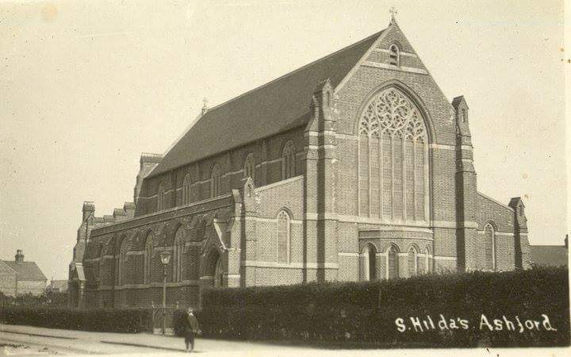
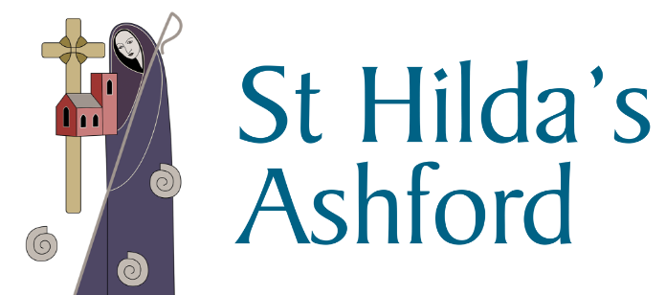 Weekly Newsletter
Photo courtesy of Chris Maddock

Contents

Churches must stayed closed until July – Church Times, 11 May 2020

Thy Kingdom Come – Introduction to the Global Prayer Movement
Lockdown – A short story by Carolyn Clark.
Reflections - VE Day (75) 2020 – Christina Veasey writes.

Our thoughts and prayers – Those from this weeks notices

If you would like help or to speak to a member of the ministry team please contact the office on 01784 253525 or office@sthilda.org Father Joseph can be contacted on 01784 254237.
Churches must stay closed until July

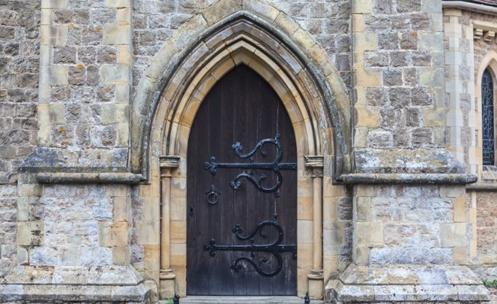
THE Government has lumped churches with pubs, cinemas, and hairdressers as premises that must stay closed at least until 4 July. A detailed document released on Monday, after the Prime Minister’s broadcast statement on Sunday night, speaks of churches as part of “Step Three” in the journey back to normal life while the coronavirus remains a threat.
Step One begins on Wednesday, with encouragement from the Government to return to work where this can be done safely.
Step Two, to take place no earlier than 1 June, would involve a phased return to school for primary-aged children, the opening of non-essential shops, and the careful expansion of social groups.
Step Three, at the start of July, allows for further easing, assuming that infection rates have not risen again. The document states: “The ambition at this step is to open at least some of the remaining businesses and premises that have been required to close, including personal care (such as hairdressers and beauty salons) hospitality (such as food service providers, pubs and accommodation), public places (such as places of worship) and leisure facilities (like cinemas).
“They should also meet the Covid-19 secure guidelines. Some venues which are, by design, crowded and where it may prove difficult to enact distancing may still not be able to re-open safely at this point.”
The document states that no change will be made to the instructions for funerals, which allow a few family members and friends to attend services in crematoria or at outdoor burials.
There is, however, a hint that weddings might be allowed in three weeks’ time. The document states: “We understand the frustration couples planning a wedding must be feeling, so we have set out our intention to enable small wedding ceremonies from 1 June. As with all coronavirus restrictions on places of worship, venues and social distancing, we will look to ease them as soon as it is safe to do so.”
The document also raised the prospect that face covering might need to become standard for churchgoing. “People should aim to wear a face-covering in enclosed spaces where social distancing is not always possible and they come into contact with others that they do not normally meet, for example on public transport or in some shops.
“Homemade cloth face-coverings can help reduce the risk of transmission in some circumstances. Face-coverings are not intended to help the wearer, but to protect against inadvertent transmission of the disease to others if you have it asymptomatically.
“A face covering is not the same as a facemask such as the surgical masks or respirators used as part of personal protective equipment by healthcare and other workers. These supplies must continue to be reserved for those who need it. Face-coverings should not be used by children under the age of two, or those who may find it difficult to manage them correctly.”
The document also repeats advice about preventing the spread of the coronavirus, including maintaining the two-metre distancing rule, washing hands frequently, washing clothes regularly, and keeping indoor areas well ventilated.
The Bishop of London, the Rt Revd Sarah Mullally, who has been leading the C of E’s response to the crisis, responded to the statement by recognising that it was still right to restrict public worship. “We note from the Government’s Covid-19 Recovery Strategy that churches could be open from July as part of the conditional and phased plan to begin lifting the lockdown. We look forward to the time when we are able to gather again in our church buildings.
“We are examining what steps we will need to take to do so safely and are actively planning ahead in preparation.
“We strongly support the Government’s approach of continuing to suppress the transmission of the virus and accordingly, we recognise that at this time public worship cannot return in the interests of public health and safety.”

Thy Kingdom Come – 21st May 21st – 31st May

Thy Kingdom Come is a global prayer movement that invites Christians around the world to pray from Ascension to Pentecost for more people to come to know Jesus.
Since its start in May 2016, God has grown Thy Kingdom Come from a dream of possibility into a movement. In 2019 Christians from 172 countries took part in praying ‘Come Holy Spirit’, so that friends and family, neighbours and colleagues might come to faith in Jesus Christ.
During the 11 days of Thy Kingdom Come, it is hoped that everyone who takes part will:
- Deepen their own relationship with Jesus Christ
- Pray for 5 friends or family to come to faith in Jesus
- Pray for the empowerment of the Spirit that we would be effective in our witness
After the very first Ascension Day the disciples gathered with Mary, constantly devoting themselves to prayer while they waited for the outpouring of the Holy Spirit at Pentecost. Like them, our reliance on the gift of the Holy Spirit is total – on our own we can do nothing.
Through the centuries Christians have gathered at that time to pray for the coming of the Holy Spirit. ‘Thy Kingdom Come’ picks up this tradition. Over the past three and a half years more and more worshipping communities have dedicated the days between Ascension and Pentecost to pray ‘Come Holy Spirit’.
We are praying that the Spirit will inspire and equip us to share the Good News of Jesus Christ with our friends and families, our communities and networks. It has been amazing how many varied ways there have been in which people from every tradition have taken up this challenge. The effects have been remarkable.
It is our prayer that those who have not yet heard the Good News of Jesus Christ and his love for the world will hear it for themselves, and respond and follow Him. Specifically, we again invite each and every Christian across the country to pray that God’s Spirit might work in the lives of 5 friends who have not responded with their ‘Yes’ to God’s call.
Whether you have joined in ‘Thy Kingdom Come’ before or not, we invite you to take part this year – along with churches from over 65 different denominations in 178 countries around the world.
“In praying 'Thy Kingdom Come' we all commit to playing our part in the renewal of the nations and the transformation of communities."
Archbishop Justin Welby
"You will receive power when the Holy Spirit has come upon you; and you will be my witnesses …to the ends of the earth. When he had said this…he was lifted up, and a cloud took him out of their sight…Then they returned to Jerusalem … and were constantly devoting themselves to prayer… When the day of Pentecost had come they were all together in one place... All of them were filled with the Holy Spirit... and that day about three thousand persons were added."
Acts 1, 2
“In praying 'Thy Kingdom Come' we all commit to playing our part in the renewal of the nations and the transformation of communities."
Archbishop Justin Welby.
There are resources included with this newsletter to help you connecting with Thy Kingdom Come, during the time between Ascension Day and Pentecost.
God bless,
Fr Joseph

Please see enclosed information sheets for individuals and families.

Lockdown – a short story by Carolyn Clark

The sun trickled in under the blinds; fingers of light that beckoned to her, it’s warmth, colour and joy contrasting sharply with the room that contained her. Grey. It engulfed her from the carpet to the ceiling. Even the dull throb of the fan seemed grey. Objectively she noted that the chairs were purple, but as that was the liturgical colour of mourning she was able to dismiss it.
She longed to go outdoors, perhaps for a walk, or even to read in a lounger, or do gardening. But no, duty tied her to a laptop in this grey room. Only in her flights of fancy was she free. In her dreams she wasn’t this frumpy, fleshy, middle-aged woman with no purpose, but a woman in her prime with abounding talent and endless energy.
She had begun to see it at the start of lockdown when she had been stripped of her usual formulas and routines. The well-beaten path of the everyday had ended suddenly and that which had seemed so confining to many had seemed to her to be the gift of freedom. The gift of time. She was no longer surrounded by the usual plans and procedures, and ventured out into her neglected garden, tearing up the weeds and overgrown climbers with relish, embracing every opportunity, sowing seeds with abandon. She made plans involving reading, decluttering, baking, musical instruments and began to see that there was creativity, there was energy and vitality. Purpose.
And then it had come; that siren call back to the laptop, to the life that she had left without regret. With it returned that creeping greyness, the ennui that she couldn’t quite shake off, the lethargy, the impotence.
Despite the sunshine outside, this greyness would not lie down. How was she to resolve this dilemma? Live the everyday life, but take into it the rainbow of enthusiasm that she had glimpsed so briefly? Perhaps that was the whole function of this time for her she reasoned, to grapple with the rainbow; with the ephemeral, insubstantial joy that it symbolised. To follow it, knowing that that was the desire for her - a life lived in full spectrum colour, a life lived to the full.

REFLECTIONS – VE DAY (75) 2020
Perhaps like me, you are an avid Radio 4 listener? My early Sunday mornings include ‘Something Understood’ – a long-standing Radio 4 programme broadcast weekly at 0600 am but again at 1130pm. This Bank Holiday repeated a broadcast by the poet Michael Simmons Roberts who considered the ‘thinning out’ of the English language. He reflected on words which previously seemed more prolific in everyday language especially those used across differing genres. This Sunday’s word example was ‘Grace’ which he illustrated with clips of well-known music like; ‘Graceland’ – by Paul Simon; ‘Amazing Grace’ – the anonymous lovely hymn (**The Bridge 16), and J.S Bach’s beautiful 16th century chorale ‘Bin ich gleich von der Gewichen’ from his St Matthew Passion, among other more modern ‘grace’ music. Hence my initial reflection dignifying this important 75th Anniversary celebration.
So my day began with ‘gracious’ deliberations; how about the ‘graceful’ birds singing in my garden welcoming each day? At my garden bird station, the Magpies and Jackdaws are not gracious, but clearly bossy types; though intelligently arriving early to gratify appetites when larger claws do not easily fit around ‘fat snax’ holders! Alternatively, the sparrows are consistently joyful flying in happy troupes, whether for water or dust bathing or regularly swinging from one gracefully assured foothold to another. Amazingly, the Blackbird’s seem to spot left over cat food scraps provided from their hidden perches? While Robin(s), with superior and individual grace, clearly prefer to seek food alone! Several Woodpigeons bumble around snatching morsels ungraciously and chasing off less accepted others! Yet so differently to their elegant life-long mating Collared Dove cousins who work together divinely. The Tits, of so many sorts, bring perfectly polished poise. While the tiny Wren’s stick to insect morsels in preference. Occasionally Poshy, the noisy but beautiful pheasant remembers to bring his duller mate. Though all are surpassed by the graceful, if artful, and swift Peregrine or Red Kite, if they ever spy a meal from afar. Thankfully most times, as part of the *community of creation* - ‘grace’ and charity pervades.
Subsequently over breakfast, I remembered our 2020 Lent book ‘Saying Yes to Life by Ruth Valerio.’ In her final chapter*, Ruth suggests that “as we wake the sleeping giant of the Church, so we must wake the sleeper inside ourselves too.” She reflects that knowing about global issues, we must look after our ‘common home’ but somehow we fail to take serious actions in our own lives! Thus combine this reflection with more than 20 ‘grace’ related verbs/nouns existing in over 40 world-wide languages, and even found in signing - when the open right hand waves across to the heart.
Of course, ‘graceful generosity’ is not always possible, try as we may, but in these challenging times, Archbishop Justin writes “we are charged by our creator with taking good care of his creation.” (*ref; above)
“Through many dangers, toils and snares I have already come.
‘Tis grace that brought me safe thus far, and grace will lead me home.”
‘Amazing Grace (verse 3) by John Newton alt.,**
Surely all part of ‘saving grace!’

Isaiah 41:10

Do not fear, for I am with you, do not be afraid, for I am your God; I will strengthen you, I will help you, I will uphold you with my victorious right hand.

Appeal for sleeping bags and tents
St Hilda is committed to help those who find themselves homeless, for whatever reason, by providing sleeping bags and tents. So far it has relied on donations from the local community, but due to Covid-19 it has run out. Although more invisible than ever, homelessness has not gone away. If you have some which you no longer need, or are able to make a donation to purchase new ones, please do get in touch. It is a small step for one person, but a big step for our community, to pull together in order to help those who do not have the security of a place to stay. Thank you so much in advance.

Weekly Newsletter
Please email Denise at office@sthilda.org or Fr Joseph at Vicar@sthilda.org if you have anything to be included in the weekly newsletter.
Crossroads
Please email Rosemary at crossroads_ashford@hotmail.com if you have anything to be included in the parish magazine. The most recent edition is available on our website.

Sunday Eucharist
The 9.30am Sunday Eucharist can be viewed via our Facebook page, our new YouTube channel (St Hilda’s Ashford), and Twitter. Please see our website (www.sthilda.org) for updates and the weekly service sheet.

Birthday Celebration
Another member of the St Hilda’s family is celebrating a special birthday on Sunday 24 May
Happy 70th Birthday to Chris Morris

Please hold in your prayers and thoughts this week those who are affected by the Corona Virus as well as the family and friends of those below.

The Sick
James Bedford | Raymond Nation | Sandra Swain
Pamela Claridge | Michael O’Hagan | Rev. Peter Taylor
Robb Clarke | Elizabeth Savill-Burgess | Chick Wilson
Ann Considine | Delphine Scrivener | Peter Wilson
Michael Dixon | Riley Shaw | Jo Wood
Jim Hennessey | Anne Shenton | Nic
Penny Howell | Elsie Stone
Libby Mills | Roy Stone

The Recently Departed
Nigel Freeman | Eileen Musk | Margaret Kerr | Doris Searle
Richard | Beverly | Irene | Elizabeth Connor
Patricia Pouffou | Ronald Cobb | Mary Berry | George Brown
Donna Marshall
Prayer

Loving God, Holy One,
Your desire is for our wholeness and well-being.
We hold in tenderness and prayer the collective suffering of our world at this time.
We grieve precious lives lost and vulnerable lives threatened.
We ache for ourselves and our neighbours, standing before an uncertain future.
We pray: May love, not fear, go viral.
Amen

